**Date:** 10/21/2022  
**Total hours:** 10  
**Description of design efforts:**

**PCB Design**

This week was mostly spent finishing the schematic and PCB layout for the flight controller. I took the input and corrections gathered from the midterm design review and implemented that guidance on the board design.

The critical points noted during the design review were:

* Extend pads on QFN for IMUs and FTDI
* Fix voltage divider inversion
* Add capacitor on VSense
* Remove ground plane around and beneath oscillator
* Change footprint of voltage regulator to the actual footprint, rather than a footprint of equal size and pads with improper silkscreen and boundary.

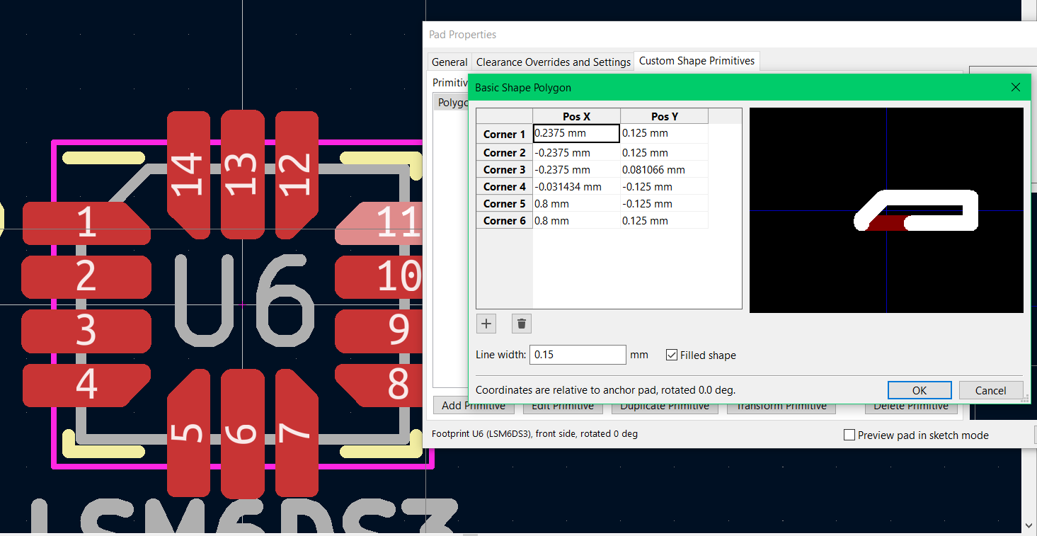

Fig. 8.1. Resizing pads on LSM6DS3 to allow for easier hand soldering.

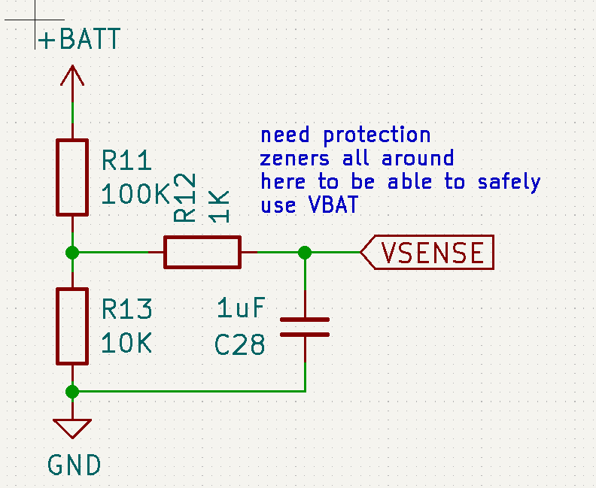

Fig. 8.2. Fixed voltage divider setup for VSense.

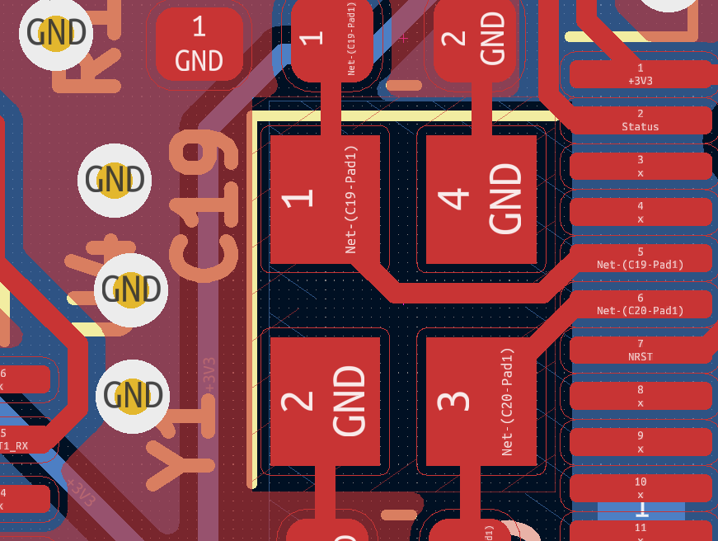

Fig. 8.3. Added keepouts below and surrounding oscillator.

The fix for the voltage regulator was significantly more involved. I first had to find a 3D model for the part itself, which luckily Pololu provides as a .STEP file, a common Autodesk part file. I then struggled with multiple export utilities, trying to find one that would export to .WRL (KiCAD’s supported 3D model filetype), but retain it’s material / color information.

After a few tries, I then imported the model file and set its position, scale and the boundary for the footprint.

Fig. 8.4. Correct 3D model of footprint.

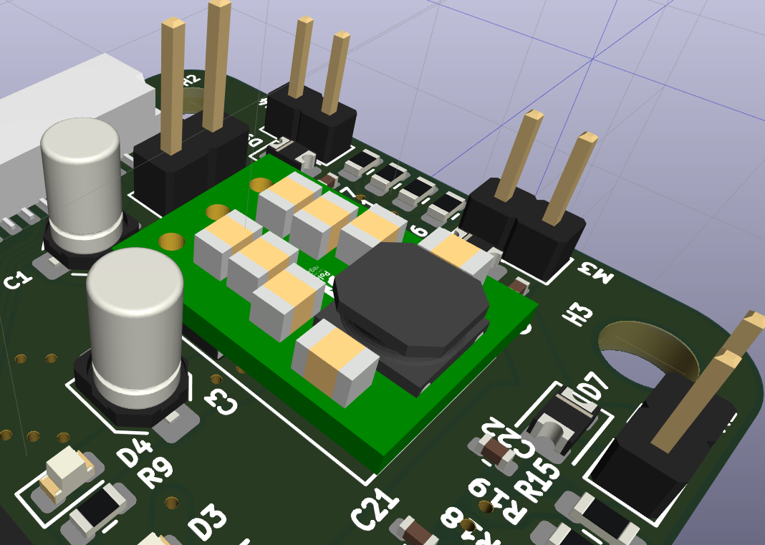

Fig. 8.5. Regulator correctly imported into rest of PCB 3D model.